**Performance Assessment 1 – Review**

In this lab you will be reviewing the networking that you have learned in your program. You will be using Packet Tracer for the lab. Make sure you save your lab work- you will be using it for the next lab as well.

Your network will a class B network based on a number assigned by your professor, which you will be using for the duration of the class. In the lab anytime you see an underline you should fill in this number.

**Student network: 10.____.0.0/16**

**Task 1 – Create the network**

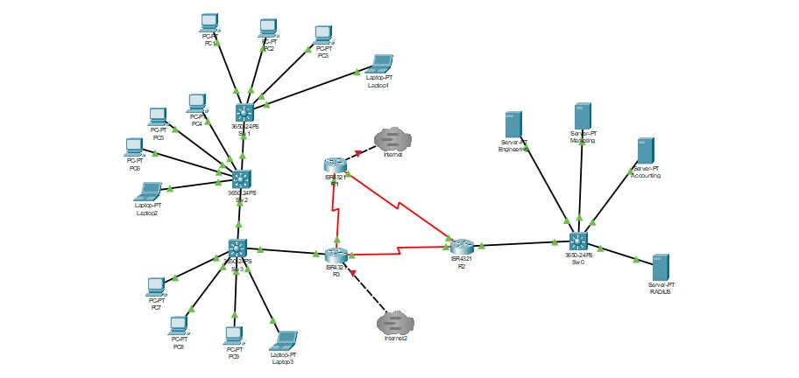

|  |  |  |  |  |  |
| --- | --- | --- | --- | --- | --- |
| **System** | **Port** | **Connect To** | **IP address** | **Subnet Mask** | **Clock Rate** |
| R1 | G0/0/1 | Internet | 11.0.0.___ | 255.255.255.0 |  |
|  | Se0/1/0 | R2 | 10.___.5.1 | 255.255.255.252 | 500000 |
|  | SE0/1/1 | R3 | 10.___.5.10 | 255.255.255.252 |  |
| R2 | G0/0/0.10 | Sw0 | 10.___.2.### | 255.255.255.192 | Engineering Server |
|  | G0/0/0.20 | Sw0 | 10.___.2.### | 255.255.255.192 | Marketing Server |
|  | G0/0/0.30 | Sw0 | 10.___.2.### | 255.255.255.192 | Accounting Server |
|  | G0/0/0.40 | Sw0 | 10.___.2.### | 255.255.255.192 | RADIUS Server |
|  | Se0/1/0 | R3 | 10.___.5.5 | 255.255.255.252 | 500000 |
|  | SE0/1/1 | R1 | 10.___.5.2 | 255.255.255.252 |  |
| R3 | G0/0/1 | Ineternet2 | 11.0.0._(+1)_ | 255.255.255.0 |  |
|  | G0/0/0.10 | Sw1 | 10.___.3.### | 255.255.255.### | Engineering- 28 users |
|  | G0/0/0.20 | Sw1 | 10.___.3.### | 255.255.255.### | Marketing –12 users |
|  | G0/0/0.30 | Sw1 | 10.___.3.### | 255.255.255.### | Accounting- 10 users |
|  | G0/0/0.40 | Sw1 | 10.___.3.### | 255.255.255.### | IT 5 Users |
|  | Se0/1/0 | R1 | 10.___.5.9 | 255.255.255.252 | 500000 |
|  | SE0/1/1 | R2 | 10.___.5.6 | 255.255.255.252 |  |

Your servers will all be on the 10.___.2.# network which will be split into four equal networks of 62 host numbers each. Refer to the help sheet for further router configuration guidance.

For R3 there are three floors of users with one switch per floor. Management would like the three departments spread out on each floor so we can have a better corporate culture.   Spread the users out on each floor but keep them in their own VLAN network with the others in their department. Refer to the help sheet for further switch configuration guidance.

                Engineering                        28 users

                Marketing                          12 users

                Accounting                        10 users

                IT administration              5 users

Set up DHCP for each network using either DHCP on one of the servers or a DHCP server on one of the routers (all pools should be at a single location).

Set up the network with OSPF protocol for the networks on each router.

*R1(config)#* ***router OSPF 1***

*R1(config-router)#* ***network 10.___.5.0 0.0.0.3 area 0***

*R1(config-router)#* ***network 10.___.5.8 0.0.0.3 area 0***

*R1(config-router)#* ***network 11.0.0.0******0.0.0.255 area 0***

For R2 and R3

*R2(config)#* ***router OSPF 1***

*R2(config-router)#* ***network 10.___.5.0 0.0.0.3 area 0***

*R2(config-router)#* ***network 10.___.5.4 0.0.0.3 area 0***

*R2(config-router)#* ***network 10.___.2.### 0.0.0.63 area 1***

*R2(config-router)#* ***network 10.___.2.### 0.0.0.63 area 1***

*R2(config-router)#* ***network 10.___.2.### 0.0.0.63 area 1***

*R2(config-router)#* ***network 10.___.2.### 0.0.0.63 area 1***

*R3(config)#* ***router OSPF 1***

*R3(config-router)#* ***network 10.___.5.4 0.0.0.3 area 0***

*R3(config-router)#* ***network 10.___.5.8 0.0.0.3 area 0***

*R3(config-router)#* ***network 10.___.3.### 0.0.0.### area 1***

*R3(config-router)#* ***network 10.___.3.### 0.0.0.### area 1***

*R3(config-router)#* ***network 10.___.3.### 0.0.0.### area 1***

*R3(config-router)#* ***network 10.___.3.### 0.0.0.### area 1***

Pull a **show ip route** from the border router. Take a screenshot

Ping from the R1 router to the engineering server. Take a screenshot

**Deliverables**

* Screenshot of working network
* Screenshot of your DHCP server or router pools
* Screenshots of *ipconfig* from PC1, PC5, and PC9 and Laptop3 (each device off of a separate switch and in a spate VLAN)
* Screenshot of ***show ip route*** from R1
* Screenshot of a *ping* from R1 to the Engineering Server

PASTE SCREENSHOTS BELOW

**Task 2 – Connecting to the Tier1 Network**

You will be using the Multiuser link to connect your corporate office through the Internet. First, make sure you have the multiuser connection on your packet tracer network. This icon looks like a cloud with three lines in it (not the cloud without them).

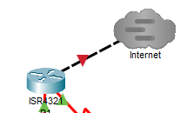

Go to Extensions at the drop-down menu and select multiuser and Listen.

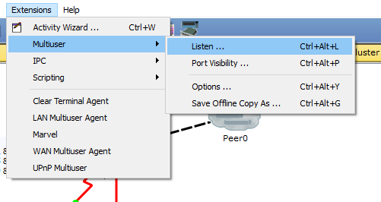

Remove the password (if any) and select always accept to both existing and remote networks.

Now click through Extensions and Port visibility

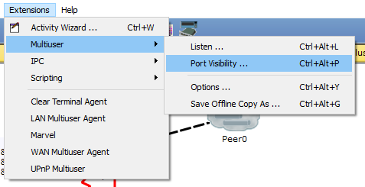

Select your ports of G0/0/0 and G0/0/1 on the R1 router and the G0/0/1 on the R3 router. These are the ports that will be available for connection to external users.

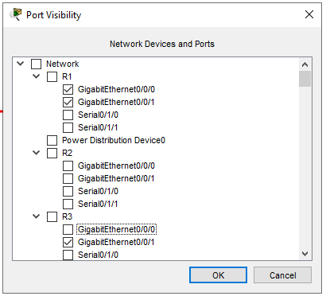

Open you Tier1Network and verify that you have the following network

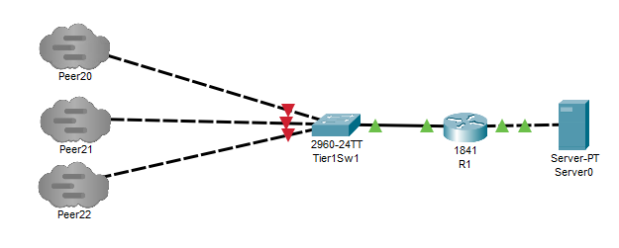

Verify the port number of your Tier1 Network by looking at the listen page of the multiuser dropdown menu. Write your port number below.

Port number ______________________________________________________

Click on the Multiuser cloud and type localhost and Peer port number for your tier1 network. You should use the Peer name of Peer20 on your connection.

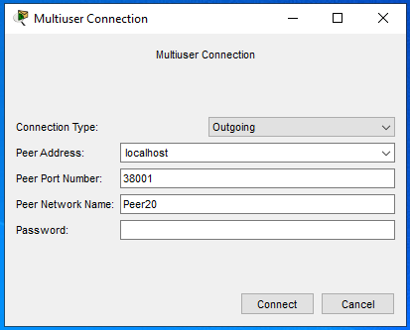

Click the connect button. You should now see the Peer connection cloud appear on the packet tracer screen as green or blue.

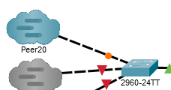

Wait for the connection to turn green on both sides. If the connect stays red you may need to disconnect and reconnect the cable going to the cloud. Select the link at the top of the cloud, not create a new link so you can connect to the system on the other side of the link.

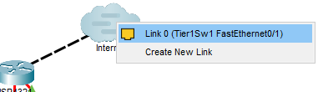

Check your connection to the Tier1 Network by going to R2 and pulling **show ip route**. Take a screenshot.

Ping the Tier1 Internet server with PC9. Take a screenshot.

Now place a second Multiuser cloud from the R3 router as shown below. Connect the second Multiuser cloud to the Tier1 Network. Pull a **show ip route** from the R2 router. Take a screenshot.

What is the difference between the **show ip route** displays on R2 after the second cloud is connected? Why do you now see two routes to the 11.0.0.0/24 and 11.1.1.0/24 networks?

**Deliverables**

* Screenshot of *show ip route* from the R1 router
* Screenshot of a *ping* from PC1 to the Tier1 Internet server.
* Screenshot of *show ip route* from the R2 router
* Answer the question about show ip route displays

PASTE SCREENSHOTS BELOW